## The Arc Tools

There are three arc-based tools in RapidPlan, the **Arc** tool, the **Pie Arc** tool and the **Road Arc** tool. All of these tools are created from a radius, making perfect curves.

**To use an arc tool:**

* Select the necessary arc tool from the Tools palette.
* Click once to set the radius of the arc.
* The second click is where you draw your arc by moving the cursor in the direction of the arc.
* Click to complete the object.
* Right click to drop the tool.

You can also specify numeric values for the radius, start angle and end angle for the arc.

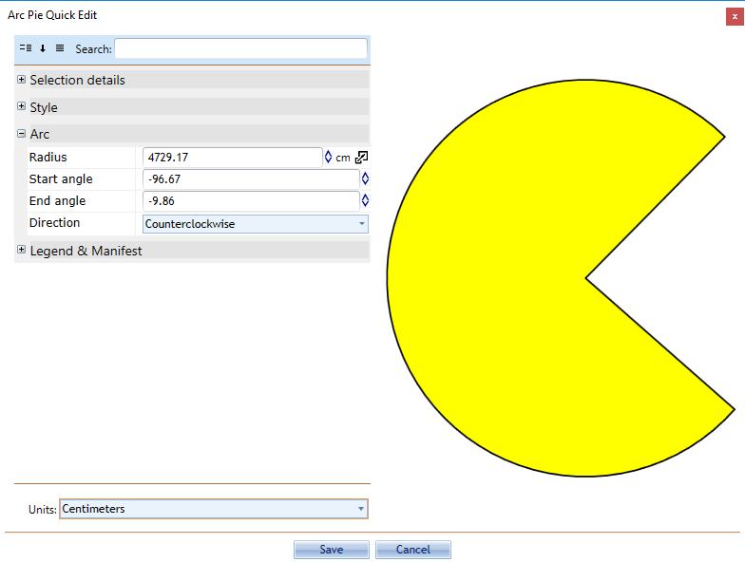

Setting_the_Radius_and_Angles_of_the_Pie_Arc_Manually